Chapter 10, Problem 48.

Find i_{o} in the circuit in Fig. 10.93 using superposition.

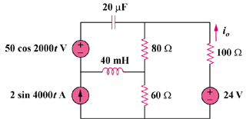

Figure 10.93
For Prob. 10.48.

